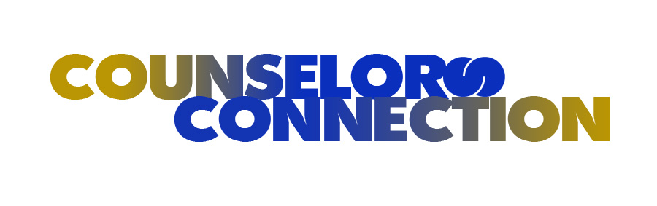

A bimonthly newsletter from the guidance counselor/social worker staff

A Publication of PS/MS 95, The Sheila Mencher School

November 2016

When To Seek Help For Your Child’s Behavior

Wishing everyone a safe, happy, healthy holiday season from our PS/MS 95 family to yours!

It can be difficult to determine if your child’s behavior or conduct warrants seeking professional help. If you are receiving frequent phone calls from a teacher or counselor at your child’s school and his or her behavior is not improving, it might be a good time to seek help from an outside source. According to *The National Institute of Mental Health*, the warning signs of a behavior disorder include but are not limited to the following:

Upcoming Events

November 3rd – ½ Day of School for Students – Parent Teacher Conferences

November 8th – Election Day – No School

November 11th – Veterans Day – No School

November 24th & 25th – Thanksgiving Recess – No School

December 14th – 3G Boutique

December 26th – January 2nd – Winter Recess – No School

* Harming or threatening themselves, other people, or pets
* Damaging or destroying property
* Lying or stealing
* Not doing well in school, skipping school
* Consistent hostility toward authority figures and frequent tantrums/arguments
* Difficulty managing impulses and regulating emotions
* Behavior that does not respond to discipline

A good rule of thumb for when to seek help is if your child’s behaviors are interfering with his or her daily life. For example, if your child is constantly being removed from class for disruptive, aggressive, and/or defiant behavior, this conduct is likely interfering with his or her education. In addition, if you have a child who is unable to maintain positive, healthy relationships with peers, he or she may need professional help.

It is also a good idea to seek help if your child’s behavior is not developmentally appropriate. It is common for a three-year old child to throw temper tantrums. However, if a seven-year old child is throwing himself or herself on the floor every time he or she is angry, there might exist some type of underlying developmental or mental health problem that should be evaluated by a professional.

A mental health professional or child expert can also teach parenting skills or can help families uncover alternative discipline techniques. Often, effective consequences can help to turn a child’s behavior around. Providing support and training to parents can lead to fast results when it comes to behavior problems.

Early intervention is often the key to successful treatment and can help address the problem before it gets worse. If you suspect your child’s behavior problems aren’t normal, speak to your child’s pediatrician or school counselor. Communication between school and home leads to positive student motivation, better grades, and a reduction in at-risk behaviors. When caregivers learn how to utilize behavior modification techniques and are willing to partner with their child’s school, the chance of success is much greater.

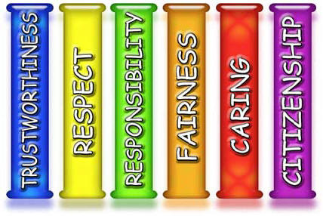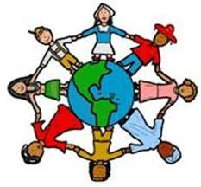 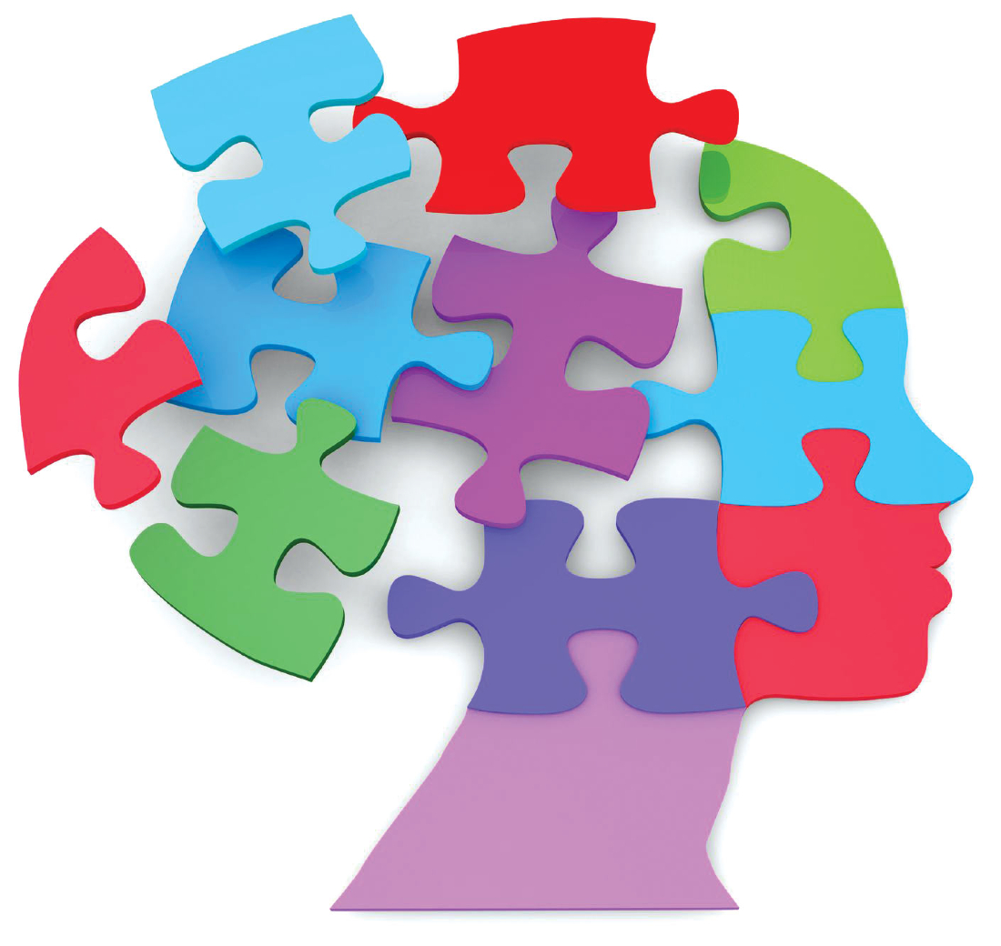

**HOMEWORK STRATEGIES**

Getting a child to complete their homework can be a daunting task. Try setting up a homework space with all their books and supplies. Some distractibility can also be a good thing. Research has shown that having background music actually helps the brain to focus better. Giving children 15 minutes of relaxation time before they start their homework can also be helpful. Even having children engage in a physical activity before sitting down to do work increases their ability to stay focused dramatically. Focus

on hard work, not intelligence.

Did you know there are plenty of free educational websites to help your child learn in a safe and fun environment? The following websites include games, online teaching, printables, videos, and so much more!

1. PBS Kids
2. Starfall
3. CoolMath
4. Make Me Genius
5. TIME for Kids
6. Nat Geo Kids
7. The KIDZ Page
8. How Stuff Works
9. Fun Brain
10. Nick Jr.
11. Scholastic
12. Disney Jr.
13. Exploratorium
14. BBC History for Kids
15. Discovery Kids

The Six Pillars of Character

PS/MS 95 participated in a school-wide hallway bulletin board contest during the month of December. Each grade was assigned a specific pillar and needed to represent how that pillar is reflected within us, the school, and the community/world. One class per grade was chosen as the winner and will be rewarded with a class time movie and popcorn this month. All classes and grades did an exceptional job demonstrating how each pillar plays an important role in our lives.

Mental Health Resources

If you are seeking outside counseling for your child or family, the following is a list of mental health agencies in the surrounding community:

Jewish Board of Family and Children Services

750 Astor Avenue

Bronx, NY 10467

(718) 882-5000

Fordham Tremont Community Mental Health Center

2021 Grand Concourse Avenue

Bronx, NY 10453

(718) 960-0300

The Puerto Rican Family Institute

4123 Third Avenue (between 175th and 176th)

Bronx, NY 10457

(718) 299-3045

Riverdale Mental Health Center

5676 Riverdale Avenue

Bronx, NY 10471

(718) 796-5300

FEGS Bronx Center

3600 Jerome Avenue

Bronx, NY 10467

(718) 881-7600

Montefiore Behavioral Health Center

1967 Turnbull Avenue

Bronx, NY 10473

(718) 620- 5256







Guidance Counselor and Social Worker Staff

**Stefanie Lalli – Guidance Counselor** ( K – 2nd Grade)

(718) 796-9200 ext. 1620

**Ken Singer – Guidance Counselor**

(Grades 3, 4, & 5)

(718) 796-9200 ext. 3230

**Erin Ehrlich – Guidance Counselor**

(Grades 6, 7 & 8)

(718) 796-9200 ext. 4550

**Diana Owens – Social Worker**

(Grades Pre K – 8)

(718) 796-9200 ext. 4630